Project Name |  | Confidentiality Level
XX Project |  | For Recipients’ Reference Only
Project ID | Version | Document Code
 |  | Project ID_SD_001

XX Software System Design Specification



Copyright © Ruankosoft Technologies(Shenzhen), Co., Ltd.
. All Rights Reserved
Revision Record
Date | Revision Version | CR ID /Defect ID | Sec No. | Change Description | Author

Content
1 Introduction 5
1.1 Purpose 5
1.2 Scope 5
1.2.1 Name 5
1.2.2 Functions 5
1.2.3 Applications 5
2 Level 0 Design Description 5
2.1 Software System Context Definition 5
2.2 Design Considerations 5
2.2.1 Design Alternatives 5
2.2.2 Design Constraints 5
2.2.3 Other Design Considerations 6
3 Level 1 Design Description 6
3.1 System Architecture 6
3.1.1 Description of the Architecture 6
3.1.2 Representation of the Business Flow 6
3.2 Decomposition Description 6
3.2.1 Module/Subsystem 1 Description 6
3.2.2 Module/Subsystem 2 Description 6
3.3 Dependency Description 6
4 Level 2 Design Description (Optional) 6
4.1 Module Name 1 7
4.1.1 Design Description 7
4.1.2 Function Illustration 7
4.2 Module Name 2 7
4.2.1 Design Description 7
4.2.2 Function Illustration 7
5 Data Structure/Database Design 7
6 UI Design 7
7 Detailed Design of Module 8
7.1 Class1 Design 8
7.1.1 Overview 8
7.1.2 Class Diagram 8
7.1.3 Attributes 8
7.1.4 Methods 8
7.2 Class2 Design 9

Keywords:
Abstract:
List of abbreviations: Describe abbreviations in this document, full spelling of the abbreviation and Chinese explanation should be provided.>
Abbreviations | Full spelling | Chinese explanation

- Introduction

Purpose
This document describes the process of software development and development of the details to facilitate the development of developers

Scope
    - Name
Super Contract Manage System

    - Functions
refer to Software Requirements Specification
    - Applications
This Software is a web application.
- Level 0 Design Description

Software System Context Definition

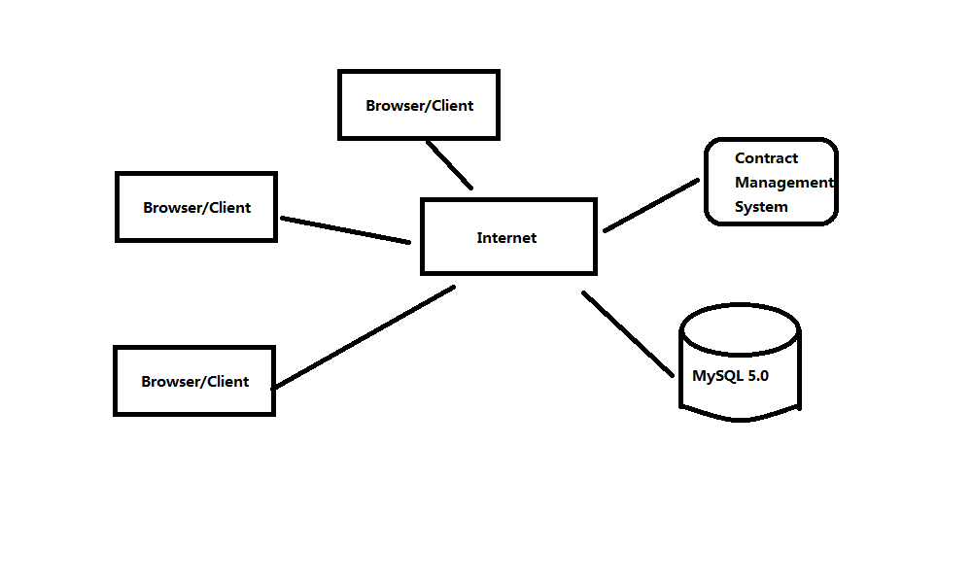Design Considerations
    - Design Alternatives
- three layer structure of system
A system can be divided into view layer,business logic layer, and data access layer,packet respectively are (com.ruanko.web),(com.ruanko.service),(com.ruanko.dao),they call business model class(is com.ruanko.modelthe class of packets) to transfer the data,some of classes are used publicly in several places, as a tool,Then put them together in a com.ruanko.utils packets.

- the developments model of project and three layer structure
A system use Model 2 development Model:JSP+Servlet+JavaBean(MVC),it combines with three layer structure ,servlet (controller) and JSP page(view) pose as view layer,JaveBean is model (including business logic,data access and entity model class and so on)pose as business logic layer and data access layer.

- the directory structure of project
The packet hierarchical structure of combine three layer structure with Model 2:
Project structure | directory
View Layer(UI) | JSP Files
 | com.ruanko.web
Business Logic Layer(BLL) | com.ruanko.service
Data Access Layer(DAL) | com.ruanko.dao
 | com.ruanko.dao.impl
Entity | com.ruanko.model

The directory of folder:
folder | Brief descriptions
css | To store style files
images | To store picture files
js | To store script files
upload | To store files to be upload

    - Design Constraints
      - Standards compliance
Hardware Limitation
CPU:1GHZ
RAM:128MB
To ensure that the system can run smoothly,the configuration best meet the following requirements:
CPU:1.8GHZ
RAM:1G

      - Technology Limitations
Database:MySQL5.X
Coding standard:CEO projecting standard requirement of Ruanko Lab.
    - Other Design Considerations
Should use the compiler Eclipse
- Level 1 Design Description

System Architecture
    - Description of the Architecture
System Architecture:
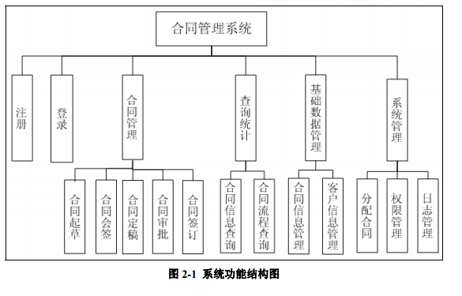
    - Representation of the Business Flow

Decomposition Description

    - Contract Manage Description
- Overview
Provide contract management process
- Functions
Management contract drafted to sign the entire process

    - Query stats Description
1. Overview
Provide query function
2. Functions
You can query the details and status of the contract
    - Basic data management Description
1. Overview
Manage information about the entire system
2. Functions
Contract information and user information management
    - System Management Description
1. Overview
Management of whole system
2. Functions
Distribution contract, rights management and log management
    - Register and log in Description
1. Overview
Log in and register
2. Functions
Log in and register

Dependency Description
- 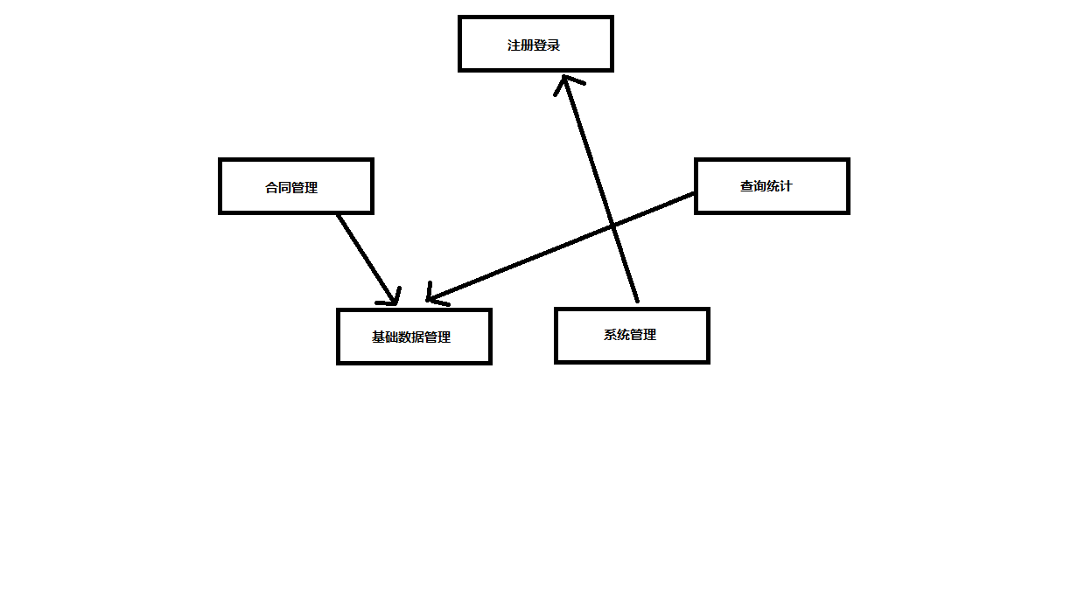Level 2 Design Description (Optional)
Each module that is defined in L1 and identified for further description shall be stated by separate sub-sections as mentioned below. More sub-section levels could be added optionally, and finally all specific classes corresponding to each final minimal module, including its public attributes and pubic methods, should be defined.
This will be repeated for each package/module as follows.

Module Name 1
Don't actually write "Module name (1)". Specify the name of the module in few words.
    - Design Description
Depict the decomposition of the modules e.g. the functionality of each sub modules. The design classes should be defined here, class diagrams could be used to describe the design classes and the relationships among these classes, and the design pattern(s) should also be interpreted.
This will be repeated for each class as follows.
      - Class name1
Should be replaced by a true design class name.
Specific classes corresponding to each final minimal module should be defined as below.
(1) Overview
Overview of its responsibilities.

(2) Definition (Optional)
Class diagrams or pseudo codes could be used to depict the class definitions in detail，if it is not described previously. All the public attributes and methods should be defined specifically.
      - Class name2
(1) Overview
(2) Definition (Optional)

    - Function Illustration
Sequence diagrams or collaboration diagrams, etc. could be used to represent the relationships among the design classes and how the design classes implement their typical responsibilities.

Module Name 2
    - Design Description
      - Class name1
      - Class name2
    - Function Illustration

- Data Structure/Database Design
Store with files and arrays
- UI Design
Describe the design of each user interface
- Detailed Design of Module

Class1 Design
    - Overview
Recount the responsibilities and functions of the class. Sequence diagrams, collaboration diagrams, or state chart diagrams can be used to depict the realizations, if it’s not described previously. If necessary, the static and dynamic relationships with the related classes could also be described.
    - Class Diagram
Class diagram, if not described in HLD.
    - Attributes
The common data structure should be described here.
Visibility | Name | Type | Brief descriptions
    - Methods
Every method should be described.
      - Method1
(1) Method Descriptions
Prototype
Description
Calls
Called By
Input
Output
Return
Exception

(2) Implementation Descriptions
Pseudo codes could be used to depict the method definitions. This is the most important part of LLD.
      - Method2

Class2 Design

